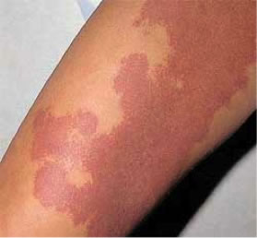
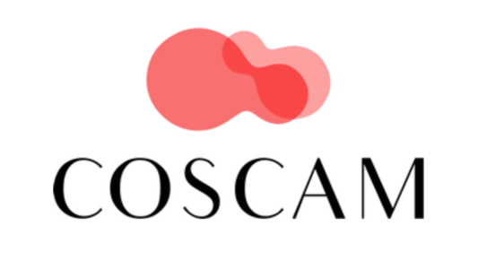

Wanted: patients with port wine birthmarks for international online study

What is the problem?
At the moment, studies on port wine birthmarks (capillary malformations) often measure different outcomes. Imagine two studies about treatment for port wine birthmarks:
Study A measures the color of the birthmark after treatment and Study B measures the number of complications.

The results of these studies cannot be compared or combined, because different outcomes were used. The variation in outcomes makes it difficult to decide what the best treatment options are.

Aim of the project
To agree on a set of outcomes (a Core Outcome Set; COS) that should be measured in all research on port wine birthmarks. This COS will be developed with the help of patients with port wine birthmarks (or their parents) and port wine birthmark experts.

How can you help us?
Provide feedback on a list of outcomes through an online survey. The study consists of 3 rounds. It takes about 15 minutes to complete the survey.

You can find the first survey via this link: https://forms.gle/Q7SWLqQFu4ccvQFu8

We appreciate your participation!

Ginger Beau Langbroek, PhD Candidate, Amsterdam University Medical Centers, The Netherlands
Contact: g.b.langbroek@amsterdamumc.nl

